Meeting notes
- Meeting every week on Tuesday practical session 1-2pm NHHB.2.12

- James, Brook, Matt present
- Created Whatsapp groupchat
- James created group repository: <link>
- Created individual repositories

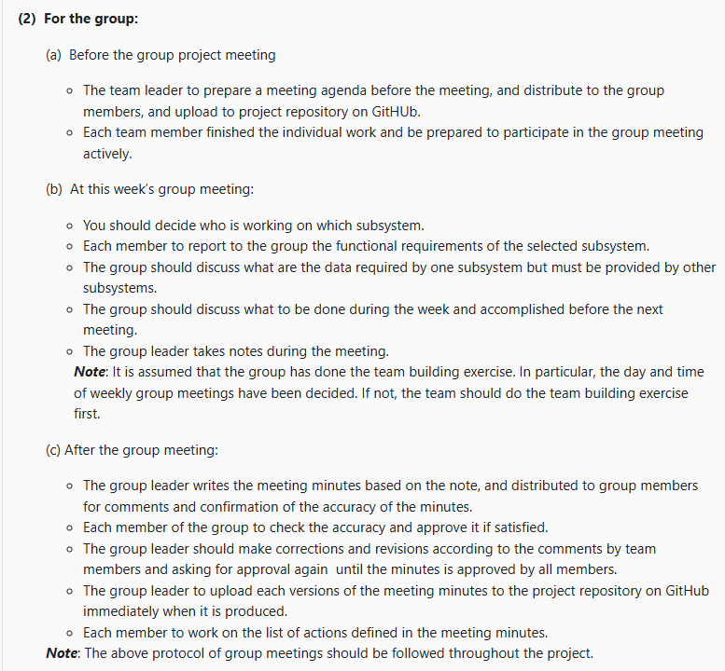

I think we needed to do this stuff in the last practical but i guess we can just do it next week?

